[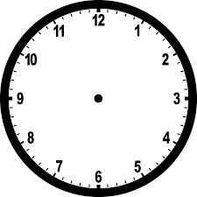](http://www.google.com/url?sa=i&source=images&cd=&cad=rja&uact=8&ved=0CAgQjRw&url=http://etc.usf.edu/clipart/48400/48481/48481_nclockb.htm&ei=fedeVLiaDZLtoAT98IDQCQ&psig=AFQjCNG-1QjBSsNa8wnQhj1HgGxTy2ivdQ&ust=1415592189297697)

[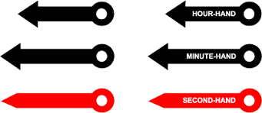](http://www.google.com/url?sa=i&source=images&cd=&cad=rja&uact=8&ved=0CAgQjRw&url=http://www.handwritingforkids.com/handwrite/manuscript/clock/craft-clock.htm&ei=_-deVMb7B9G6ogSElYDgDA&psig=AFQjCNFSTaiTIQ9XGNrOl4AuOaiPWfs5Ow&ust=1415592319200318)